This first thing is to get your system ready so that you can follow along with the course material.

For building Deep Learning models, it is required that you have the proper hardware and software setup to run the code. Let’s look at the hardware requirements

# Hardware requirements for Deep Learning:

Generally a system with the specifications mentioned below is quite suitable to train the deep learning models that we will use in this course. This system should at least have

* Intel i5 or i7, 7th generation or above
* 8GB of RAM
* 1TB of storage
* 4 GB of Nvidia Graphics Card

If you have such a system, you can install the necessary software and go ahead to build deep learning models.

However, everyone does not have the luxury of such specifications in their systems. Running a model on a system with modest specifications would have an extremely high runtime. So, there is another way to build deep learning models, which is to use a cloud system, which gives you these things without the hassle of setting up.

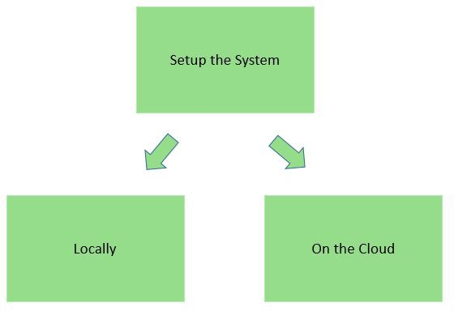

For this course, it is preferable to use cloud services such as **Google Colab**. The next unit covers how to get started with cloud.

On the other hand, if you already have the appropriate hardware, you can opt for a local setup of the software. Let’s see how we can setup the software in the system locally

# Software requirements for Deep Learning:

For this course specifically, we are using Python language throughout the coursework, specifically the Python 3 version. This is because we need you to get up to speed with the current industry code standards as fast as possible, and we think that Python is the best way to enable it.

Also, we won’t be writing every little bit of code from the ground up. Instead, we will use prewritten libraries which give you a hassle-free experience in creating end-to-end deep learning applications. For a Data Scientist, here are a few notable libraries he/she must know about

* **Numpy** - for basic math and linear algebra functions
* **Pandas** - for structured data operations and manipulations
* **Matplotlib** - for data visualization and plotting
* **Scikit-learn** - for building machine learning models
* **spaCy** - for text preprocessing

Now the easiest way to set up all the above mentioned libraries in your local system is by installing the Anaconda Package Manager that would install all the necessary libraries for you.

## Step 1 - Install Anaconda Package Manager

To install anaconda in your local system, you can follow along with the video below - based on the operating system you are using.

* [Anaconda Installation for Windows](https://www.youtube.com/watch?v=2OVJqur6pTc)
* [Anaconda Installation for Linux](https://www.youtube.com/watch?v=8ncLJxO2MCg)
* [Anaconda Installation for Mac](https://www.youtube.com/watch?v=rPmW6T9FY4w)

Now as we saw previously that we need GPUs to run the models faster, and GPUs depend on NVIDIA drivers to run. So you have to install the drivers in your system

## Step 2: Install NVIDIA drivers for GPU usage

First select the operating system for which you want to install the drivers, and the follow the steps given in the guide links below

For windows -

<https://docs.nvidia.com/cuda/cuda-installation-guide-microsoft-windows/index.html>

For linux - <https://docs.nvidia.com/cuda/cuda-installation-guide-linux/index.html>

For Mac - <https://docs.nvidia.com/cuda/cuda-installation-guide-mac-os-x/index.html>

After this, you have to install the deep learning libraries

## Step 3: Install Deep learning libraries - Pytorch and Transformers

You have already used Keras in the course “Fundamentals of Deep Learning”. In this course, we will use PyTorch and Hugging Face’s Transformers libraries.

**Install PyTorch and Transformers**

1. PyTorch installation - *pip install torch torchtext torchaudio*
2. Transformers installation - *pip install transformers*